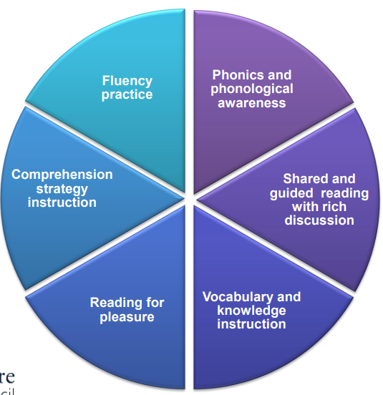
h
Reading skills taught in learning journeys:
visualisation, asking questions, forming an opinion, get the gist, connect to prior knowledge, note text structure.
Year 6 SATs training units February-May
Fluency, vocabulary, direct retrieval and inference using SATs questions prompts.
All children every week
Take part in Reading for Pleasure where they have the opportunity to try a new author or genre, read in a pair or a group, or just get lost in a great book.
Visit the school library.
Hear their teacher read to them several times.

Reading at Kings Furlong Junior School
Early readers – synthetic sounds programme
RWInc sessions 4x a week with trained LSAs and progress tracked rigorously.
Sound charts in all classrooms and sound cards used by RWInc children when writing.
RWInc children assessed for phonological awareness and groups are organised based on outcomes.
(Refer to Early Reading Policy for more details)
Home reading

All children are expected to read at home at least 4 times a week.
Early readers
On RWInc programme
Decodable book and a colour band book.
Moving On
Completed RWInc and with reading age below 11.03
Colour band book
Accomplished readers
Reading age above 11.03
Treasure Chest books followed by free readers.
Clarify lessons in each journey to teach unfamiliar vocabulary so children can unlock the text.
Immersion lessons where appropriate
eg. background of the ‘Charge of the Light Brigade’, segregation before reading ‘Young, Gifted and Black’.

Children have eyes on print in every learning journey.
Texts include fiction, non-fiction, poetry, heritage texts and a range of writers.
Extended reading learning journeys in each year group.
Every English learning journey also has significant immersion in texts to inspire or imitate.
Every reading learning journey has at least 2 fluency sessions – one in the teach unit and one in the apply unit.
Children off RWInc and with a reading age between 8 and 9 are fluency tested and tracked to inform input and support in lessons.

