World Book Day 2026 – Costume Ideas

Mr Bump
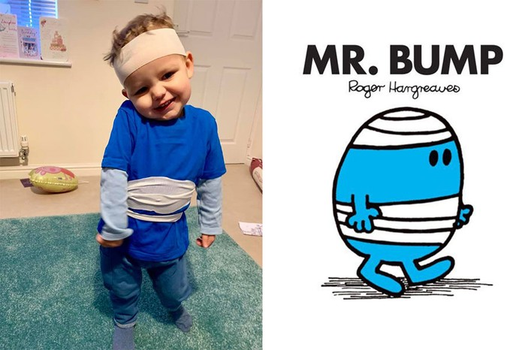
What you'll need:
- Blue top and trousers
- Bandage (if you have one) or toilet roll (if you don’t) to wind around your child's head and middle

What the LadyBird Heard
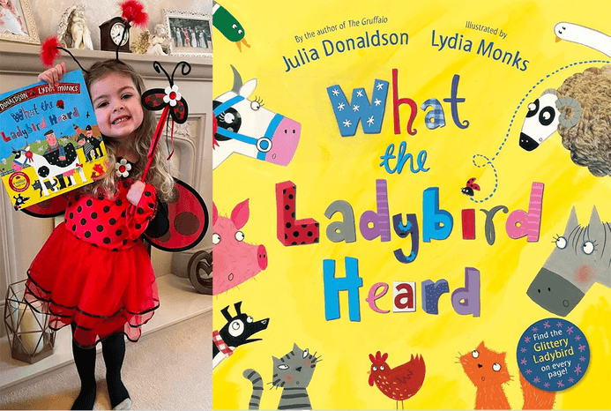

What you'll need:
- Red dress or skirt and top (decorate by adding circles of black paper for spots)
- Fairy wings
- Headband — use black pipe cleaners and red pom poms to stick to the headband for antennae

Paddington
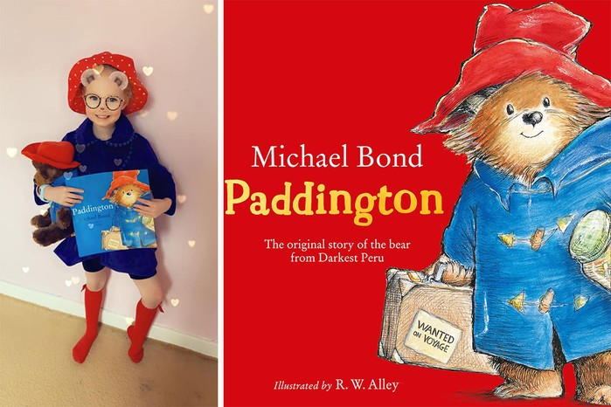
What you'll need:
- Red hat
- Blue coat or blue clothes
- Red socks
- Suitcase (optional)

Mr Twit from The Twits
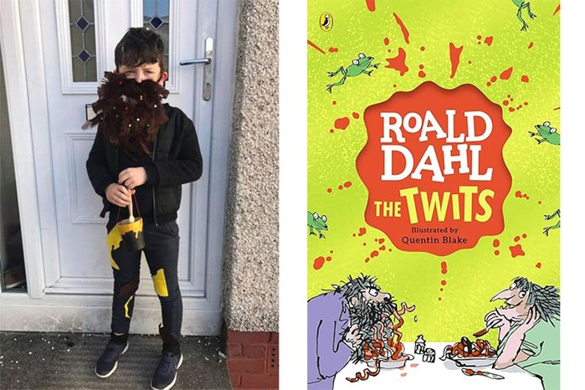
What you'll need:
- A fake beard (buy one online or make one with dark brown wool)
- Dark, messy clothes
- A paintbrush and pot

Dog Man
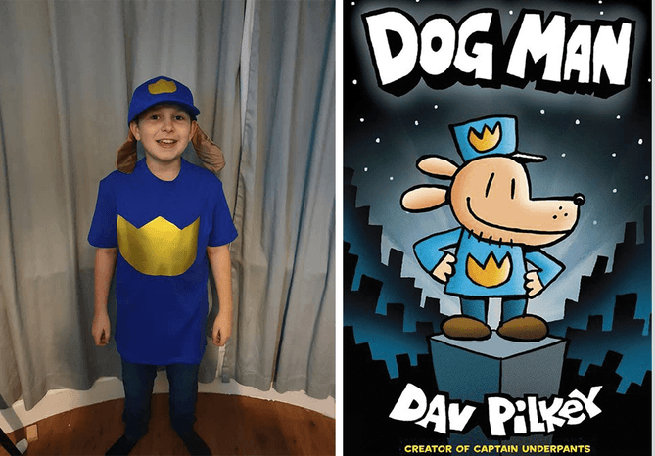
What you'll need:
- A blue t-shirt and blue cap plus jeans and brown shoes
- Fake ears (make using any brown material)
- Gold paper
- Face paint (if you want to add a dog face)

Witch from Room on the Broom
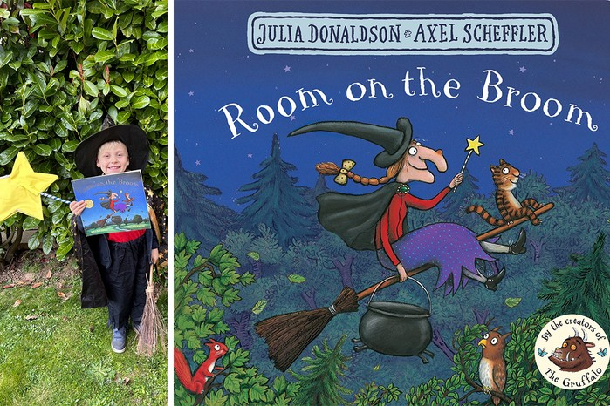
What you'll need:
- Red top
- Dark coloured trousers or skirt
- Black cape
- Witch's hat and broomstick, if you have them
- Wand made from yellow card on a stick
- Toy cat (optional)

Supertato
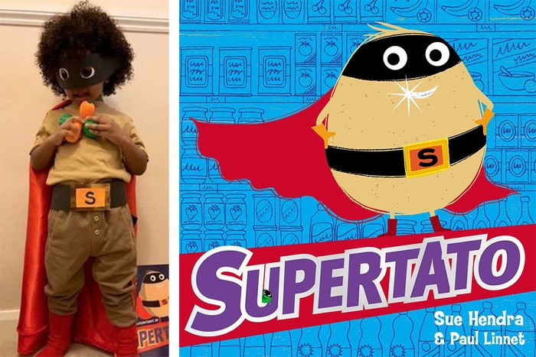
What you'll need:
- Black belt with cardboard S stuck on the buckle
- Brown clothes
- Mask (band of black paper with eye holes cut out)
- Red material/shirt for cape
- Play veg

Charlie Bucket from Charlie and the Chocolate Factory
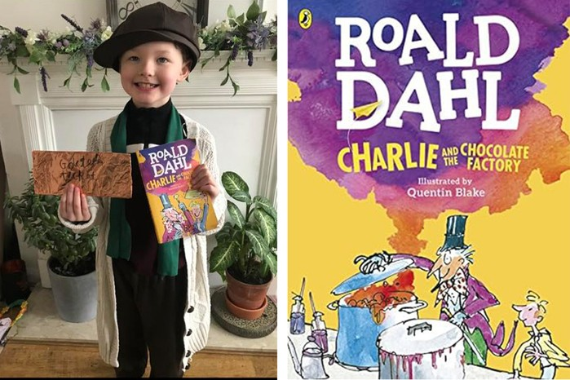
What you'll need:
- Scruffy clothes or an old jumper/cardigan
- A golden ticket – use some yellow card or cut out a section of a yellow cereal box, then write 'Golden Ticket' on the reverse side
Gangsta Granny
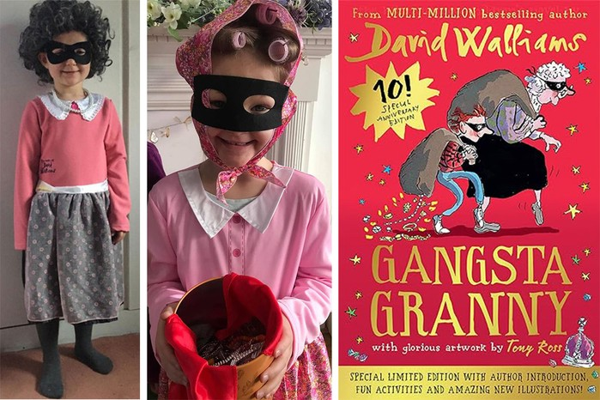
What you'll need:
- Bandit eye mask (or paint one on with black face paint). Or glasses
- Pink or mauve jumper or cardie
- White shirt with 'Granny style’ collar
- Skirt
- Slippers
- Tights – preferably too big, so they can wrinkle around the ankles
- Sack-style bag filled with scrumpled up paper (so it's not too heavy)
- A headscarf (with rollers in the hair) or, if you're feeling creative a granny wig

Wally from Where's Wally?
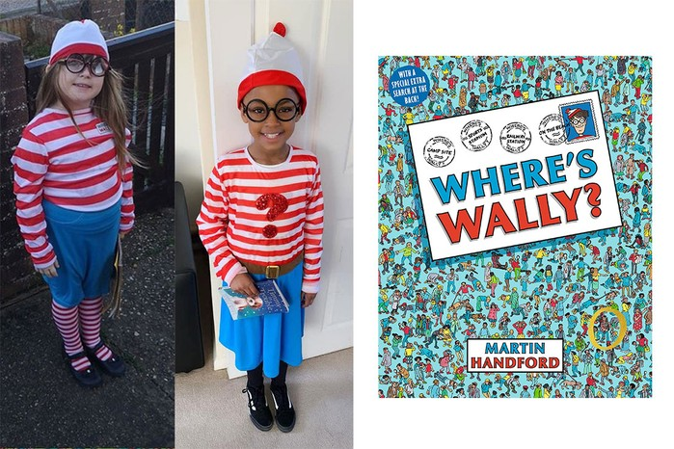
What you'll need:
- Stripey hat
- Stripey top
- Stripey socks or tights — if you have them
- Round glasses

Wednesday Addams from The Addams Family
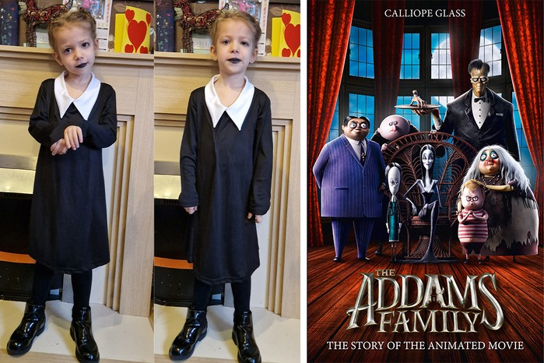
What you'll need:
- A dark dress
- A white collar — use a school shirt underneath the dress
- Black tights
- Black shoes or boots
- Black lipstick or face paint (optional)

Billionaire Boy
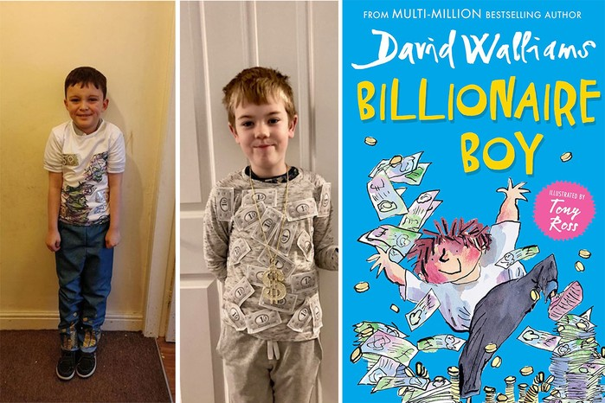
What you'll need:
- Grey or dark trousers
- Big white top
- A wallet full of money (make fake notes with paper or use Monopoly money)
- For a more fun idea — if you've got time — you can stick the fake money onto the top (as shown in the middle picture above)

Tracy Beaker
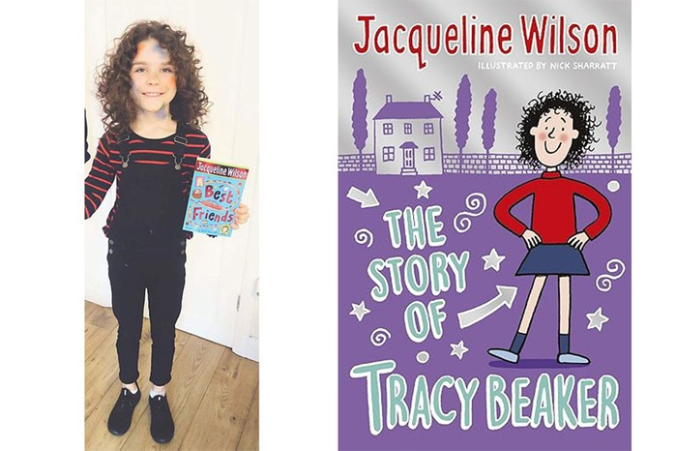
What you'll need:
- Red stripey top
- Messy dark hair (use washable spray-on hair dye or a wig, if your child's hair isn't the right colour)
- Sleeveless denim jacket

Matilda
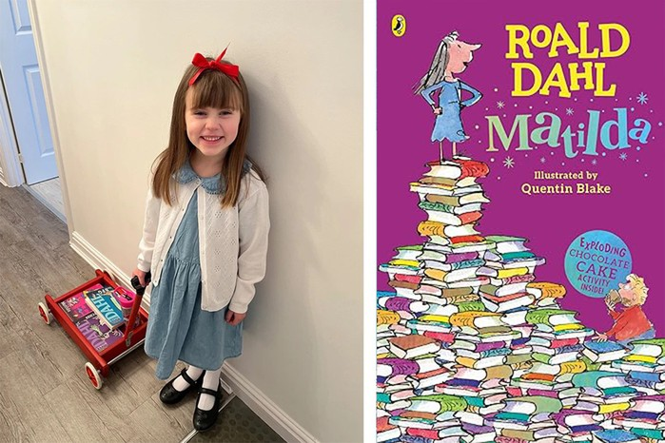
What you'll need:
- A dress, preferably blue
- White cardigan (optional)
- Red hair ribbon (if possible)
- White socks
- Black shoes

The Cat In The Hat
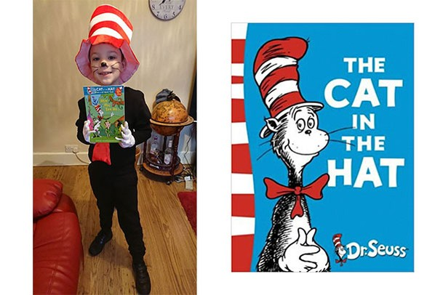
What you'll need:
- Black leggings
- Black T-shirt
- White gloves
- Red scarf
- Stripey hat – you can make this using a tube of white card and then adding a rim and painting on red stripes
- Whiskers – drawn on with an eye pencil or face paints

An English dictionary
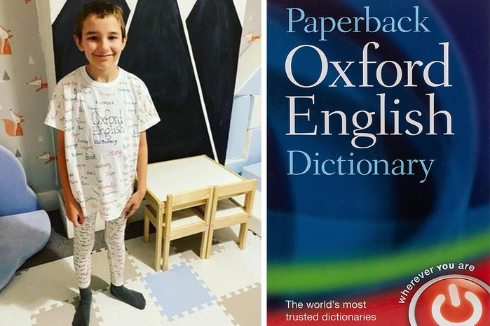
What you'll need:
- Old T-shirt
- Old leggings
- Fabric/marker pen for writing words

Greg from Diary Of A Wimpy Kid

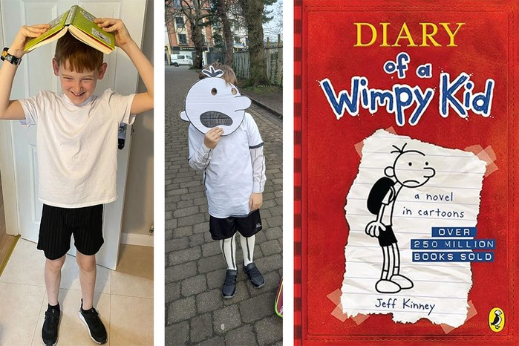
What you'll need:
- White T-shirt
- Black shorts
- Backpack
- Trainers
- White card with Greg's face drawn and cut out (optional)

The Very Hungry Caterpillar
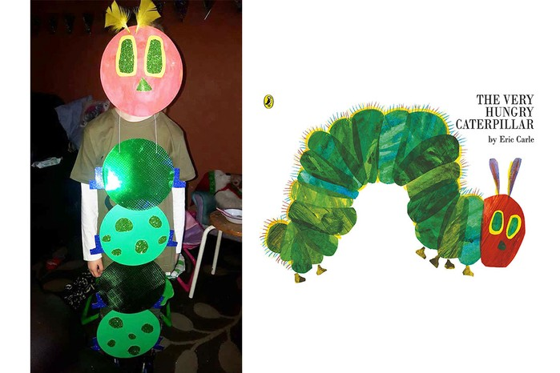
What you'll need:
- Green card and red card
- Sparkly green paper to decorate
- String
- Feathers

